Christ the King Catholic Elementary/Jr High

School Council and Fundraising Association

19.06.2025 | 6:30 PM | CTK Staff lounge | 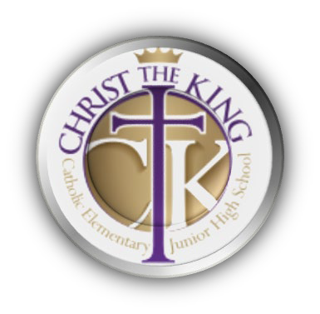  2024-2025 Year

School Council executive: | Fundraising Association executive: | Christ the King staff:
Chair, Alex G.  Vice-Chair, Blair C. Secretary, Katherine Q. Treasurer, Leah O. | Chair, Ortenzia N.  Co-Chair, Alex G. Secretary, Katherine Q. Treasurer, Leah O. Casino Chair, Anna K. | Principal, Kelly Laxdal  Assistant Principals:  - Delia De Sousa
Members at Large: | Invited Guests:
Hakiem A, Amy H,  Sangeeta M, Nick M,  Samantha L. | New Vice Principals Michelle and Kristy
Meeting Minutes

School Council
Call to Order at 6:35 pm

- New Business
  - Table approval of last meeting minutes - Pushed over to Fall - Not enough quorum.

Introductions - Round table introductions.

Two new Vice Principles:

> Michelle coming from Joan Carr School.
> Kristy coming from an all inclusive and understanding center.

- Principals Report bulletin

- Remaining Budget - $49,000. Still waiting on outstanding field trip fees and gym rental fees. With outstanding fees still coming in and existing costs, Kelly believes we will breakeven.

- Enrollment currently sits at 1171 students.

- School fees have been posted on the portal along with school supply lists, Alex will send out FaceBook posts for the parents.

- 13 new teachers - Many have a high interest in coaching.

- New Classes in the Fall - Fashion, Robotics, Leadership, ect. Total of 9 new classes for grades 7 to 9.

- Program Class Solver - Teachers input class criteria based on students, education support, female vs male, and the students get to pick 2 friends. Teachers review and give the ok.

- The ’how many days of instruction’ calendar has been posted for the 2025-2026 school year.

- Kelly and classroom teachers will maintain the weekly communications, to keep the parents in the loop.

- Teachers are hoping to post sports tryouts and Math sessions in advance on social media and school websites.

- The school is looking into participating in the Indoor Journal Games next year. Additionally, a popular suggestion is to bring Flag Football to students that are interested in participating.

- Closing Comments - Call to close 7:19pm

Fundraising
Call to Order 7:20pm

- Table approval of last meeting minutes - Pushed over to Fall - Not enough quorum.

- Fundraising Campaign Updates

- The school year ended with Root Cellar. We sold $2131 and got 20% which is $630.02

- Suggestion for Fall new school year fundraising - Steve and Dans BC Fruit.

- Healthy Hunger is completed for the school year and we received $6014.94. Suggestion for next year's organization of handing our Healthy Hunger is to assign to the students from the Leadership Program.

- The casino is officially scheduled for Oct 18th and 19th at Century Casino.
- FRA Casino Account Balance $11.570.73
FRA Main Account Balance $ 28.355.89
>> Total Fundraising Remaining $39,926.62

3. The next meeting is September 19th at 6:30pm. Call the meeting to close at 7:46pm.

