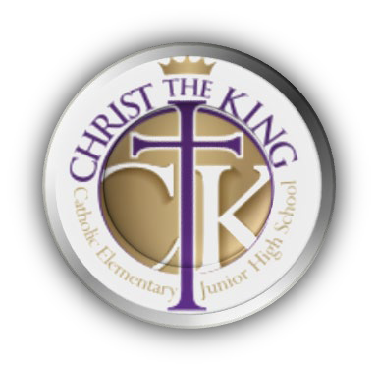


Christ the King Catholic Elementary/Jr High

06.05.2026 | 6:00 PM | CTK Staff lounge | 2025-2026 Year

School Council executive: | Fundraising Association executive: | Christ the King staff:
Chair, Alex G.  Vice-Chair, Ortenzia N. Secretary, Katherine Q. Treasurer, Blair C. | Chair, Samantha L.  Co-Chair, Alex G. Secretary, Katherine Q. Treasurer, Blair C  Casino Chair, Anna K. | Principal, Kelly Laxdal  Assistant Principals:  - Kristy McCoy  Staff Representative:
Members at Large: | Invited Guests: n/a
Leah, Sangeeta, Nick, Hakiem,

SCHOOL COUNCIL MEETING
Call to order:  - School Prayer  - Treaty 6 recognition  - Housekeeping and Introductions | Presenter:  - Ortenzia  - Alex  - Alex and Kelly
Agenda:  - New Business (5min)  - Approval of March 2026 minutes  - Principal and Admin Address (35min)  - Modulars coming  - Volunteer message from Division  - Swim to survive  - -other | Presenter:  a. Alex  Kelly and Team
Closing Comments  - Carry forward/actions items (5min)  - Next meeting, Wednesday June 17, 2026 | Presenter:  - Alex  - Alex

FUNDRAISING ASSOCIATION MEETING

Call to order:  - Call to Order  - Housekeeping | Presenter:  - Samantha

Agenda:  - Financial Report  - New Business  - Approval of March 2026 minutes (5min)  - Fundraising Campaigns updates  - Vote on CTK Staff wish list (10min)  - Hot Lunch (Firehouse Subs update)  - Cheer Uniforms, Fundraising Update(25min)  - Open floor for next meeting agenda additions (5min max) | Presenter:  FRA Exec.  - Samantha  - Samantha  - Samantha  - Alex & others  - Cheer Group  - All
Closing Comments  - Carry forward/actions items (5min)  - Next meeting, Wednesday June 17, 2026 | Presenter:  Samantha  Samantha

SPECIAL NOTES:

School Prayer

Christ the King our Lord and Savior Transform me into Yourself.
May my hands be the hands of Your work. Grant that I may live in You, by You and for You.

Land Acknowledgement

We acknowledge that we are on the traditional land of Treaty 6 and homeland of the Métis. We also acknowledge the Inuit and other diverse Indigenous peoples whose ancestors have marked this territory for centuries, a place that has welcomed many peoples from around the world to make their home here.

We, at Edmonton Catholic Schools, commit to restoring and honouring the Truth and Reconciliation calls to action; we strongly believe that truth must be acknowledged to move forward to reconciliation. Together, we call upon all our collective communities to build a stronger understanding of all peoples who dwell on this land we call home.

Council Contact Information

Email
- School Council: christtheking.schoolcouncil@gmail.com
- Fundraising Association: christtheking.fundraising@gmail.com
- Fundraising Association (casino): christtheking.frac@gmail.com

